Naan Mudhalvan Assignment

Logo:



NewsLetter:

Link : <https://www.blogger.com/blog/post/edit/5946861367732809404/5694014935394779962>

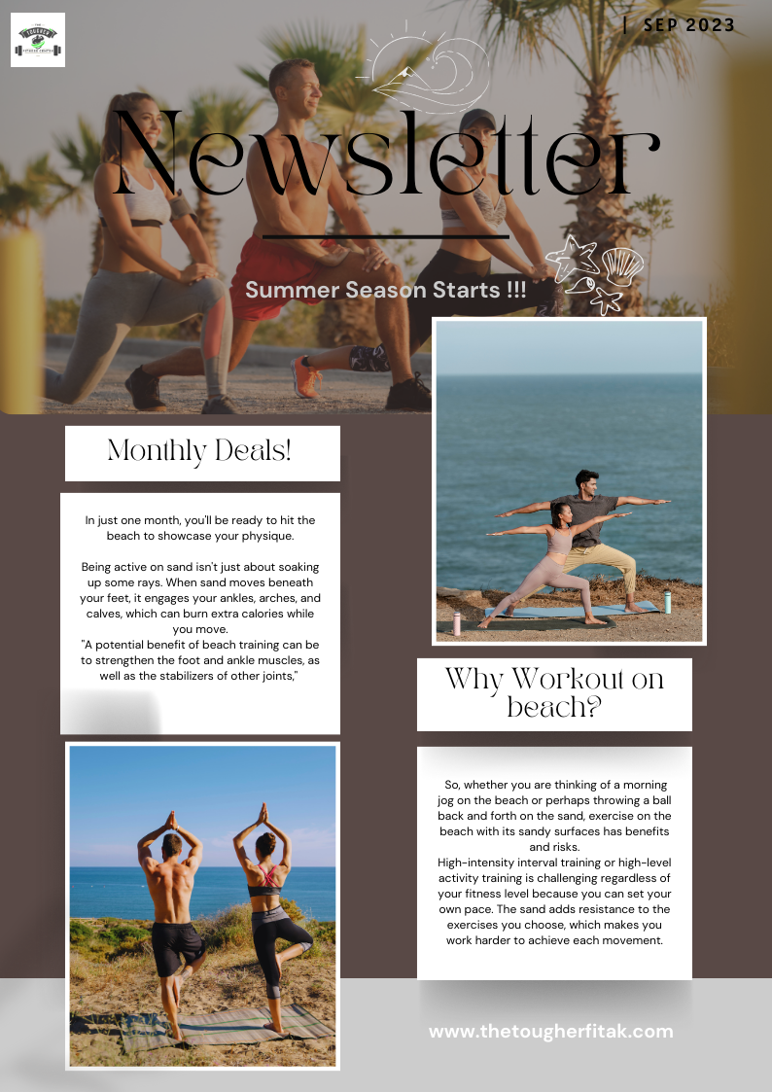

INFOGRAPHICS:

Link : <https://www.blogger.com/blog/post/edit/5946861367732809404/1739288701943298315>



Facebook Buisness Account:

Link : <https://www.facebook.com/profile.php?id=61550486286106>

